**Installation of TIBCO ActiveMatrix BPM 2.1.0 -**

Go to …\TIB_amx-bpm_2.1.0_win_x86

And double click on “TIBCOUniversalInstaller”

As a next step you will observe the below screen…. and then click “**Next**”

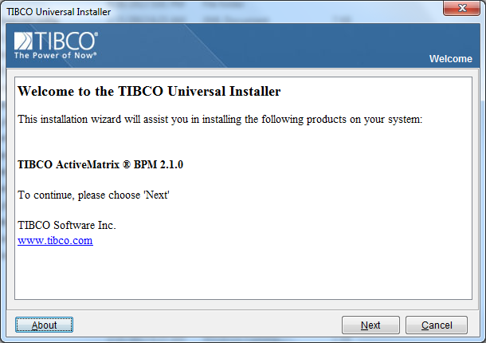

As a next step you will observe the below screen…. and then select option (1). Click “**Next**”

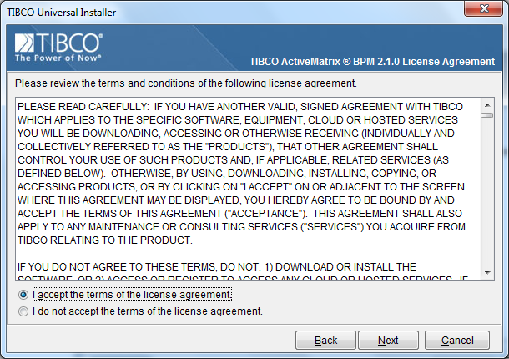

As a next step you will observe the below screen….

Check the ‘**Custom Installation’** and then select ‘**BPM’** as mentioned below…and then click on “**Next**”

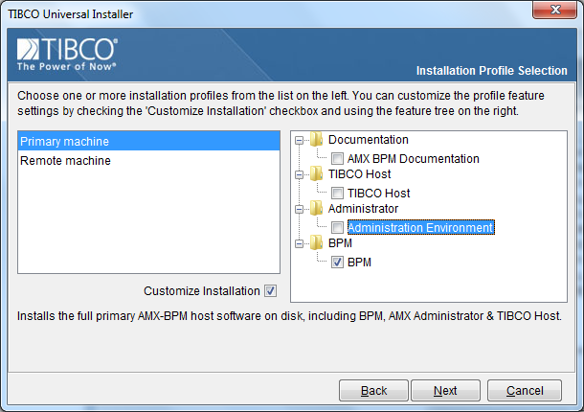

As a next step you will observe the below screen… and then click “**Next**”

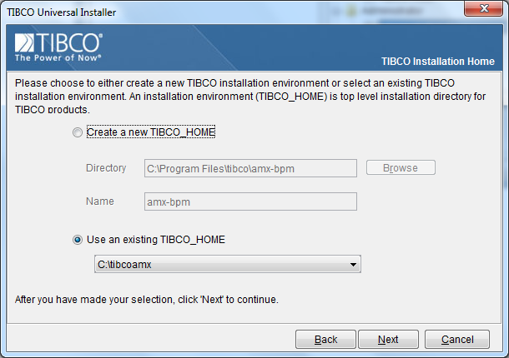

As a next step you will observe the below screen… and then check option (1). Click “Next”

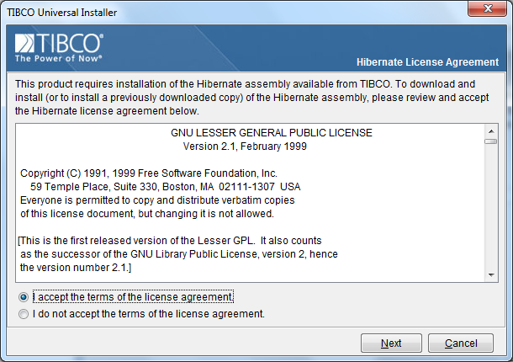

As a next step you will observe the below screen… and then click on “**No**”

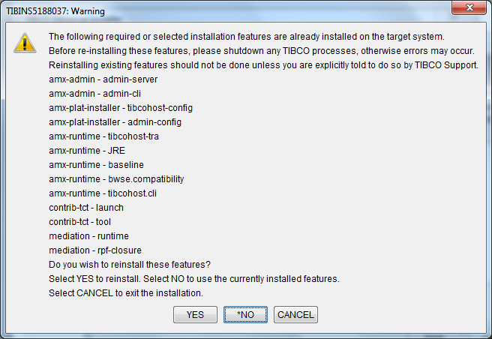

As a next step you will observe the below screen… and then click “**Install**”

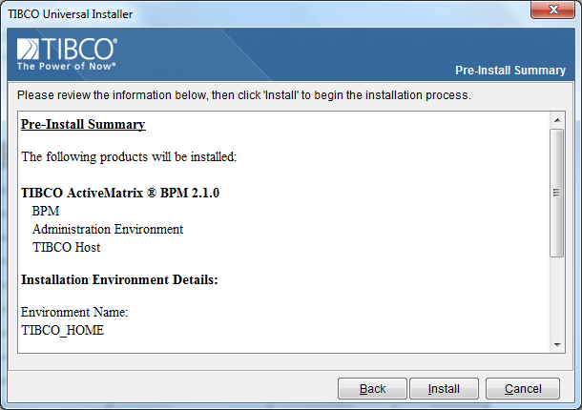

As a next step you will observe the below screen…

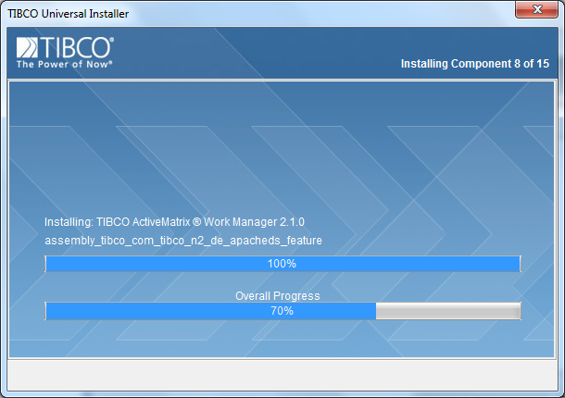

As a next step you will observe the below screen… and then click “**Finish**”

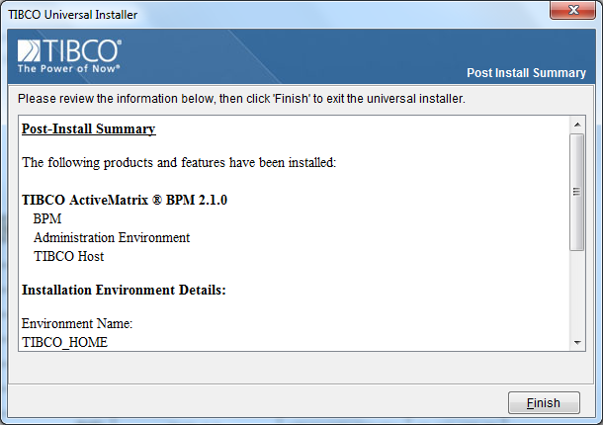

**Install the HOTFIX : TIB_amx-bpm_2.1.0_HF-005**

**Step 1: copy the HOTFIX : TIB_amx-bpm_2.1.0_HF-005.zip** fromshared location

*\\ctsintbmcelb\siemens_care_management\03 Project Operations\TIBCO Shared Location\SW\TIBCO Hotfixes*

**Step 2:** Extract the zip file into your local \temp folder. By default this **HOTFIX** folder does not contain “**TIBCOUniversalInstaller”** , hence copy the same from the above shared location and place it at the same location where you extracted the zip file i.e\temp.

**Step 3:**

Go to …temp\ **TIB_amx-bpm_2.1.0_HF-005**\

And double click the “**TIBCOUniversalInstaller**”

As a next step you will observe the below screen…and then click on “**Next**”.

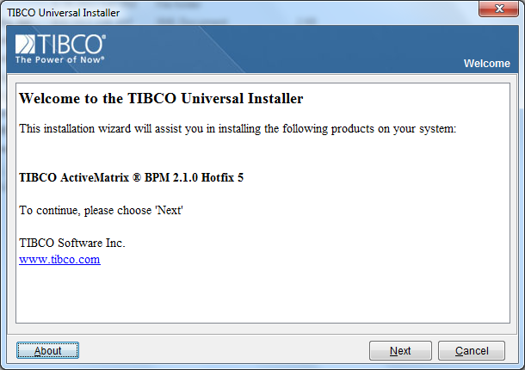

As a next step you will observe the below screen…and then select option (1). Click on “**Next**”

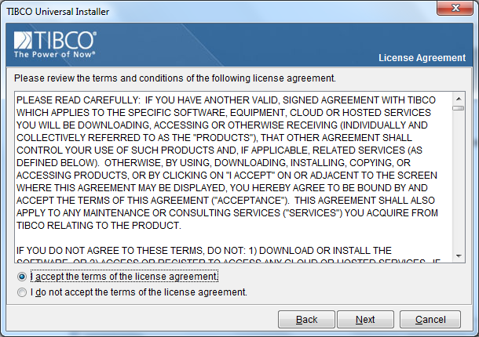

As a next step you will observe the below screen…and then click on “**Next**”.

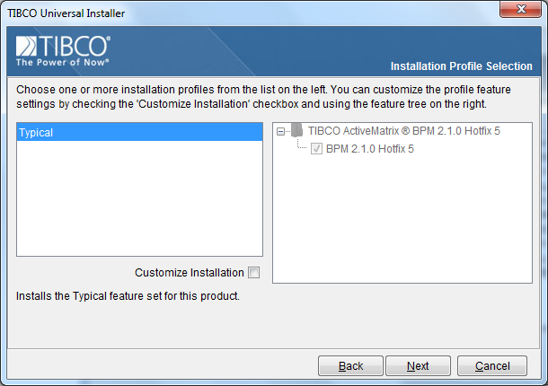

As a next step you will observe the below screen…and then click on “**Next**”.

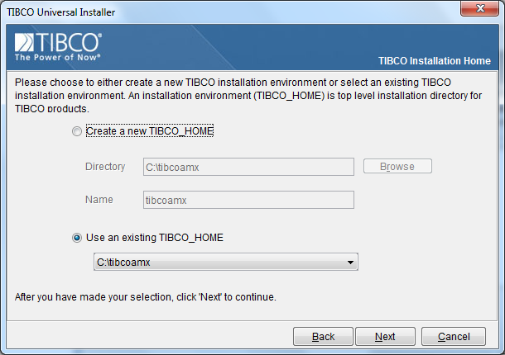

As a next step you will observe the below screen…and then click on “**Install**”.

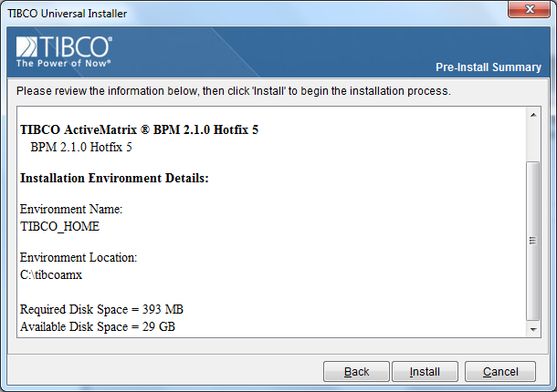

As a next step you will observe the below screen…

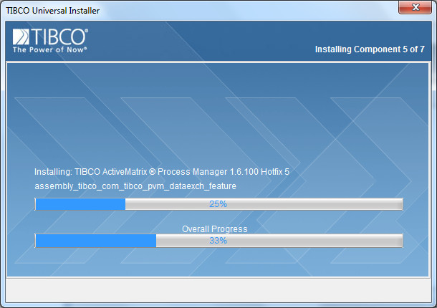

As a next step you will observe the below screen…

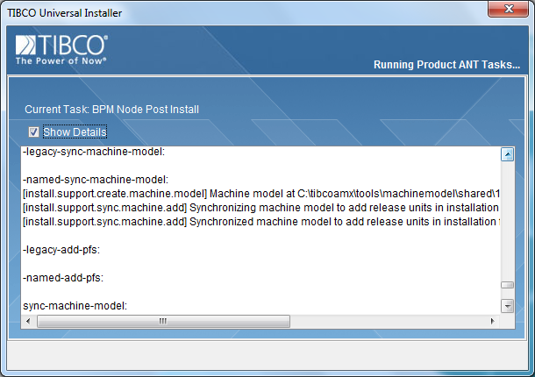

As a next step you will observe the below screen…

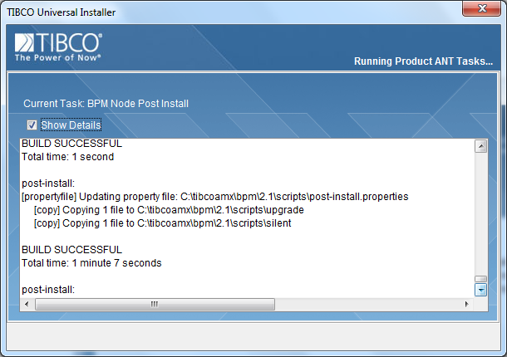

As a next step you will observe the below screen… and then click “**Finish**”

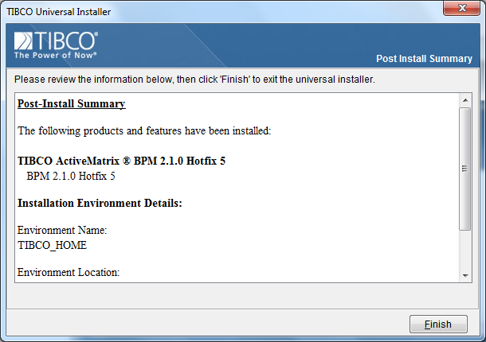

**Before configuring the Third-party Driver and BPM server do the following**

**Configuring Microsoft SQL Server 2008**

1. Create a SQL Server instance that will be used to hold the Active Matrix BPM database.

**Note :** The Active Matrix BPM database and Active Matrix Administrator server database can, if desired, use the same SQL Server database instance.

2. Configure the SQL Server instance to use mixed (Windows and SQL Server) authentication.

3. Enable the TCP/IP network protocol for the SQL Server instance.

For example:

a. In SQL Server Configuration Manager, expand SQL Server Network Configuration.

b. Click Protocols for instance_name where instance_name is the name of the SQL Server

Instance

c. Right - click TCP/IP and click Enable.

4. Enable support for XA transactions. To do this:

a. Download and install the Microsoft SQL Server JDBC Driver 3.0.0.

b. Copy the extended stored procedure dll (sqljdbc_xa.dll) from the location

where you installed the Microsoft SQL Server JDBC Driver 3.0.0 to the SQL

Server instance's Binn folder - for example, to C:\ProgramFiles\Microsoft SQL

Server\MSSQL10.MSSQLSERVER\MSSQL\Binn.

c. Run SQL Server 2008 Management Studio as an administrator of the SQL Server instance.

d. From the location where you installed the Microsoft SQL Server JDBC

Driver, run the sqljdbc_n.n\enu\xa\xa_install.sql script against the master database, where n.n is the version number of the Microsoft SQL Server JDBC Driver you are using.

**Note :** The first time you run this you may see errors about failing to drop

procedures. These errors may be ignored as the procedures do not exist yet.

e. Click Control Panel > Administrative Tools.

f. Double-click Component Services.

g. Right - click Component Services > Computer > My Computer >Distributed Transaction > Local

DTC and select Properties

h. Click Security. Select Enable XA transactions.

5. Restart the SQL Server instance.

**Configure the Third-party Driver**

Go to C:\tibcoamx\tct\1.1\

And then select the file “**TIBCOConfigurationTool”** and right click then select “Run as Administrator”.

As a next step you will observe the below screen…by default it points to the configuration location. Keep the same as it is and then click “OK”.

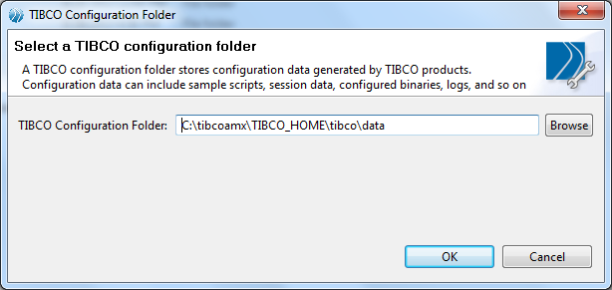

As a next step you will observe the below screen…and then select the Option (5)

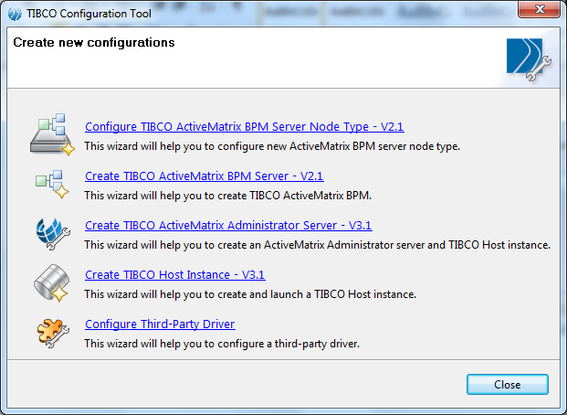

As a next step you will observe the below screen… and then select the following option,

**Driver Type** : JDBC

**Driver** : TIBCO enabled JDBC driver for Microsoft SQL Server 3.0.0

And then click “**Next**”

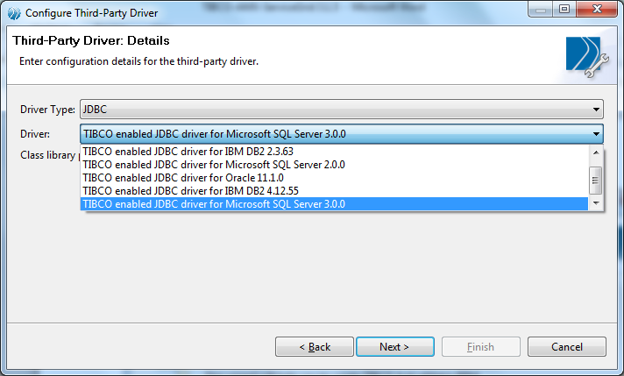

As a next step you will observe the below screen… and then point to the JAR Folder location as mentioned below. Click “Next”

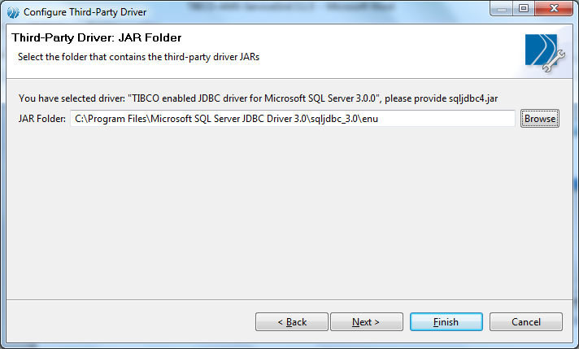

As a next step you will observe the below screen… and then click “**Configure**”

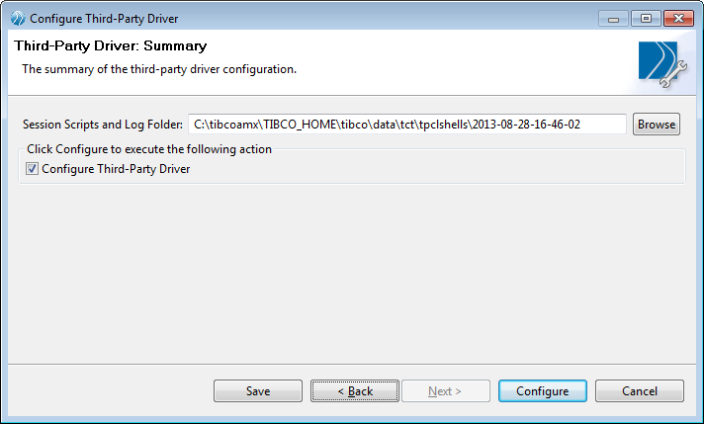

As a next step you will observe the below screen… and then click “**close**”

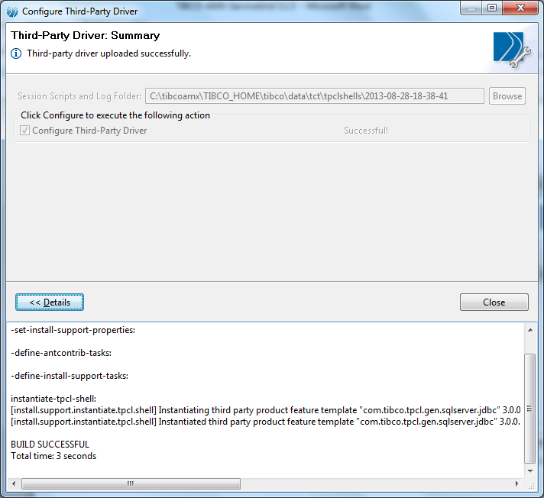

**Configure the TIBCO Active Matrix BPM Server 2.1.0**

Go to C:\tibcoamx\tct\1.1\

And then select the file “**TIBCOConfigurationTool”** and right click then select “Run as Administrator”.

As a next step you will observe the below screen…by default it points to the configuration location. Keep the same as it is and then click “OK”.

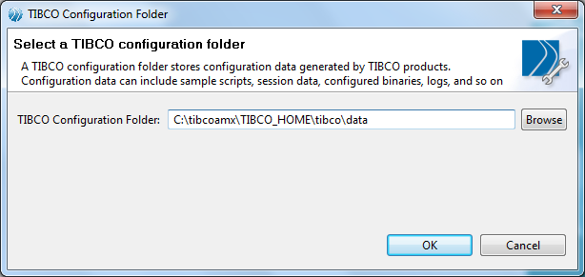

As a next step you will observe the below screen…and then select the Option (2)

**”Create TIBCO ActiveMatrix BPM Server – V2.1”**

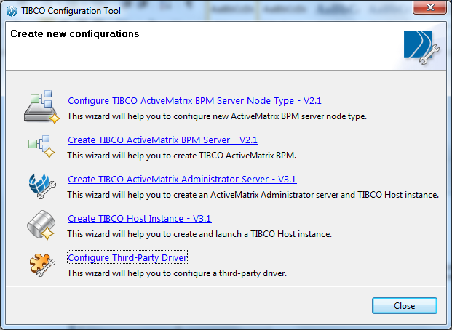

As a next step you will observe the below screen…and then click “**Next**”

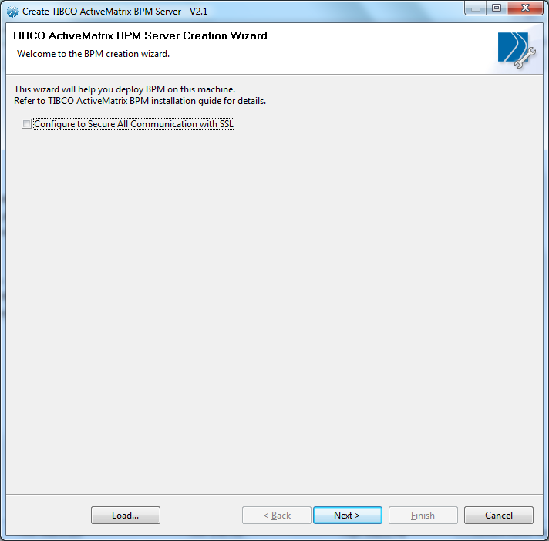

As a next step you will observe the below screen…and then configure the following as mentioned in the below screen. And then Click on “Test Connection”

**Note :**

**Database Driver**: Select TIBCO enabled JDBC driver for Microsoft SQL Server 3.0.0

**URL** : IP Address = your database server installed machine, port=<default> Database Name =master,SelectedMethod=cursor

**DBA Username** = sa

**DBA Password** = <provide the password>

Tablespace Name:<default>

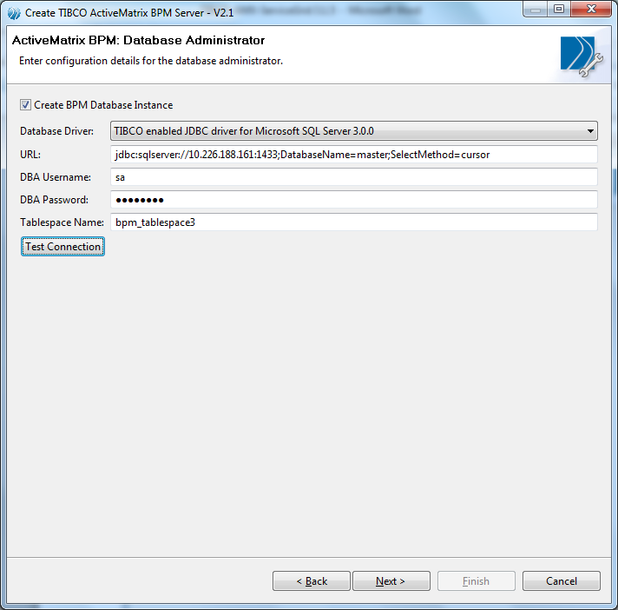

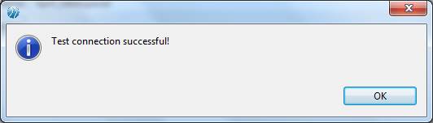

As a next step you will observe the below screen…and then configure the following as mentioned in the below screen, and then Click on “**Next**”

Database Name: BPM_Siemens_Tst2 (this name could of your choice, but meaningful)

User Name: bpmuser (this name could of your choice, but meaningful)

Password:XXXXXXX (this name could of your choice, but meaningful)

Confirm Password:XXXXXXX (this name could of your choice, but meaningful)

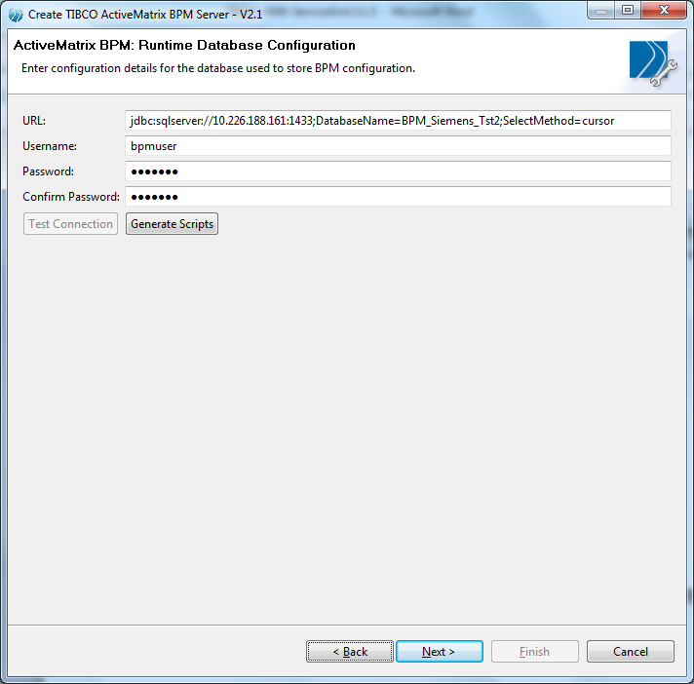

As a next step you will observe the below screen…and then change the HTTP port value from ‘8080’ to ‘38080’ and then click “**Next**”

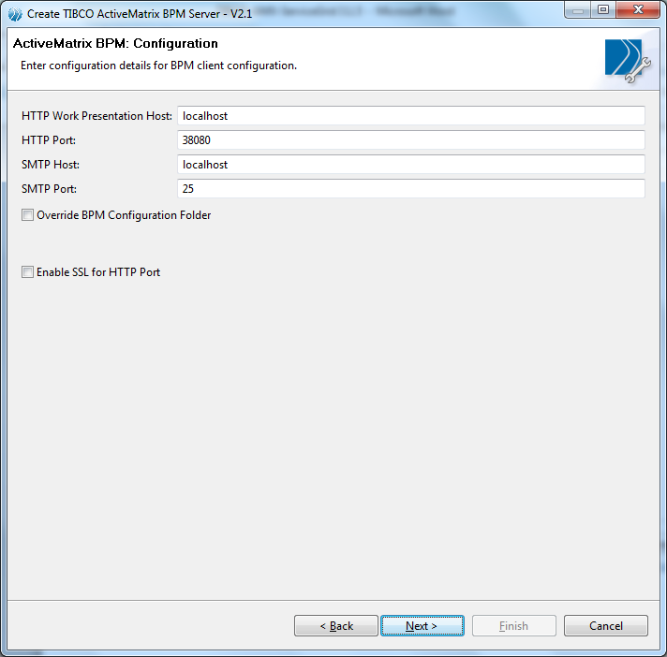

As a next step you will observe the below screen…and then click “**Next**”

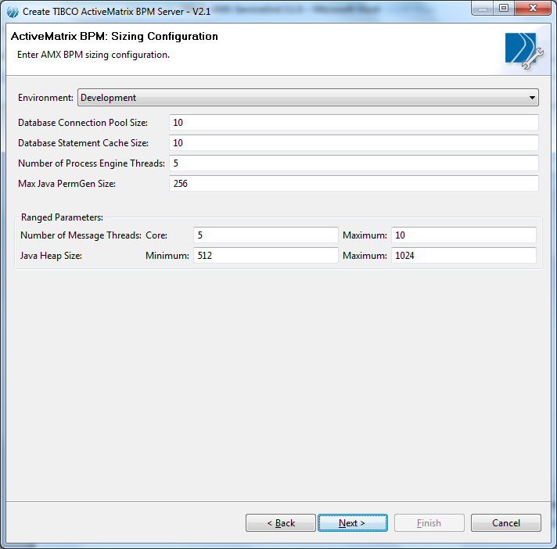

As a next step you will observe the below screen…and then click “**Next**”

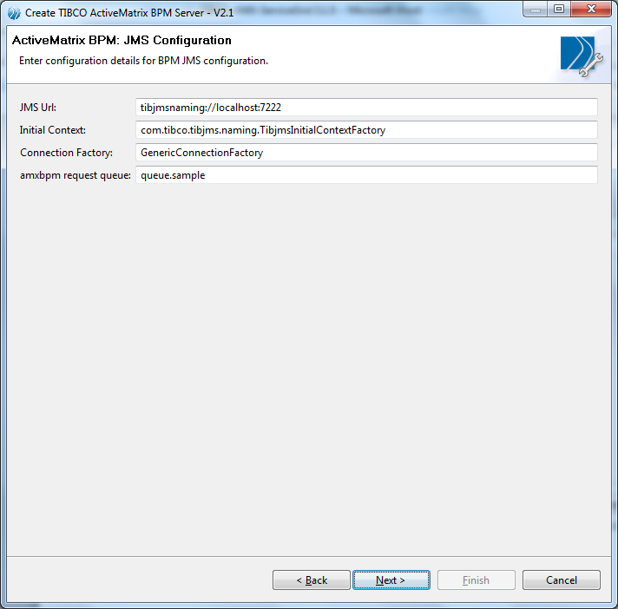

As a next step you will observe the below screen…and then click “**Next**”

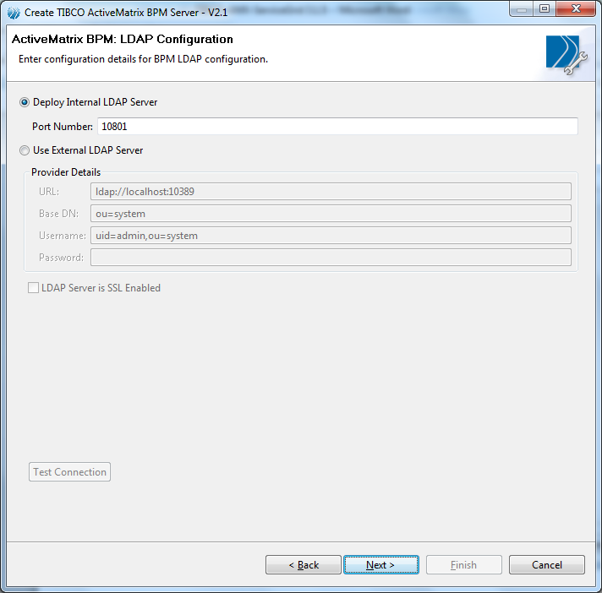

As a next step you will observe the below screen…and then configure the right port number used to configure “**Active Matrix Administration server**” during TIBCO Active Matrix Service Grid 3.1.0 configuration. Click “**Test Connection**”.

**Note** : If the “**Active Matrix Administration** **server**” is running then you will be prompted with Test Connection successful message. After that click on “**Next**” to proceed further.

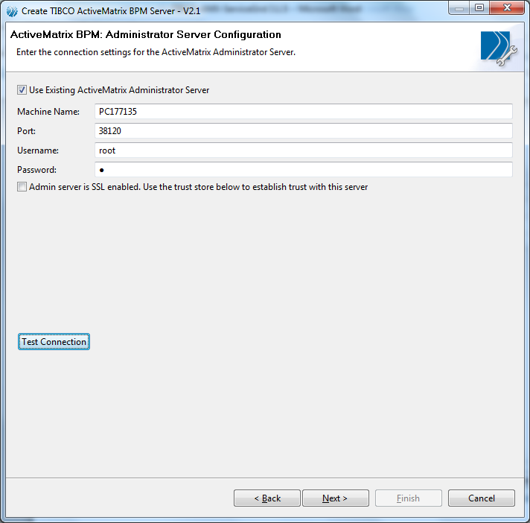

As a next step you will observe the below screen…and then click “**Next**”

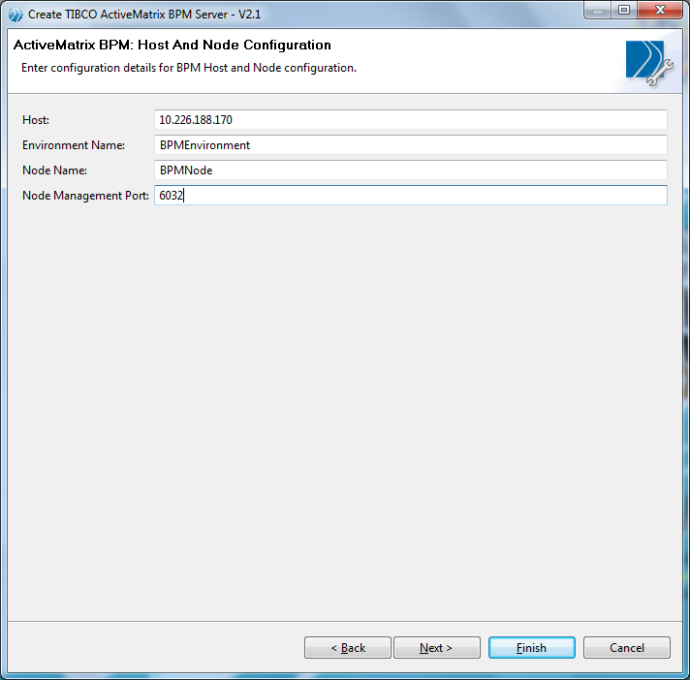

As a next step you will observe the below screen…and then click “**Configure**”

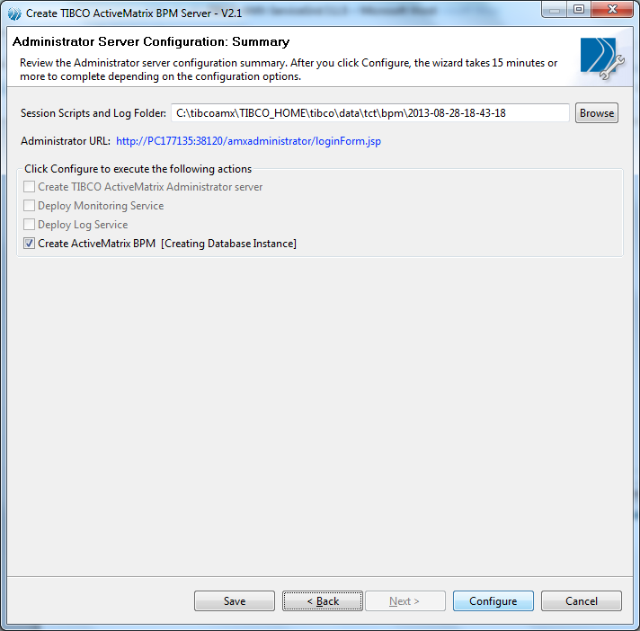

As a next step you will observe the below screen…

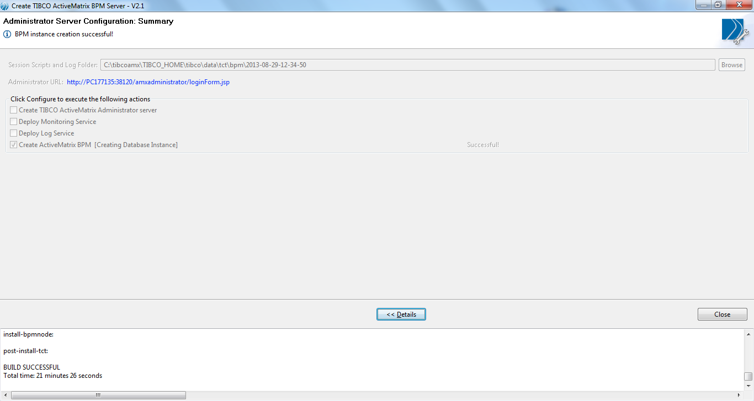

As a next step

Login to the TIBCO AMX Administrator :

URL : <http://pc177135:38120/amxadministrator/admin.jsp>

User Name : root

Password : t

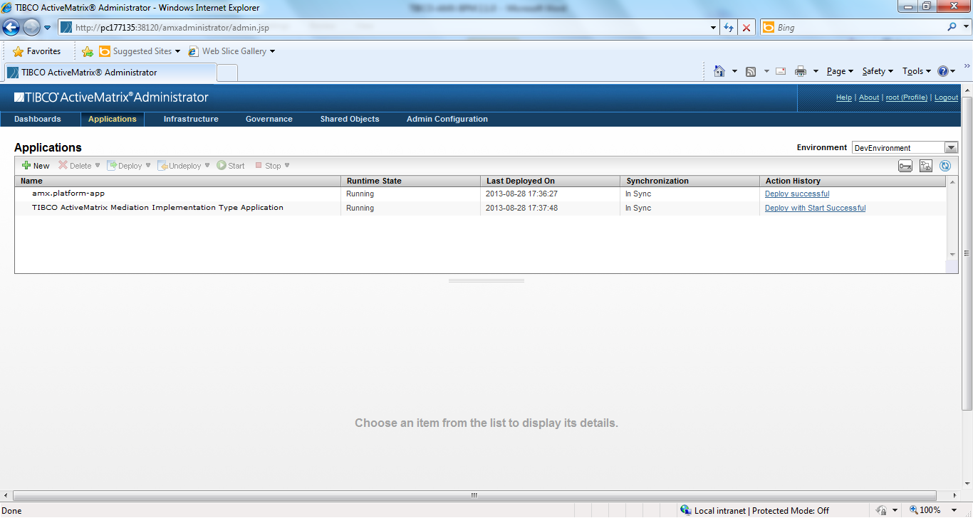

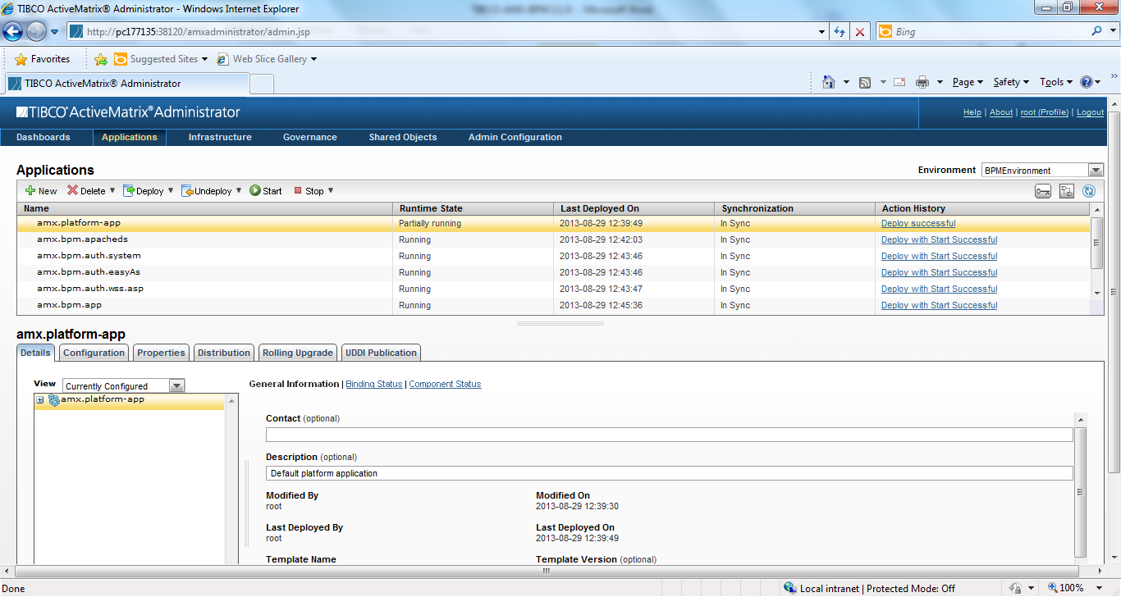

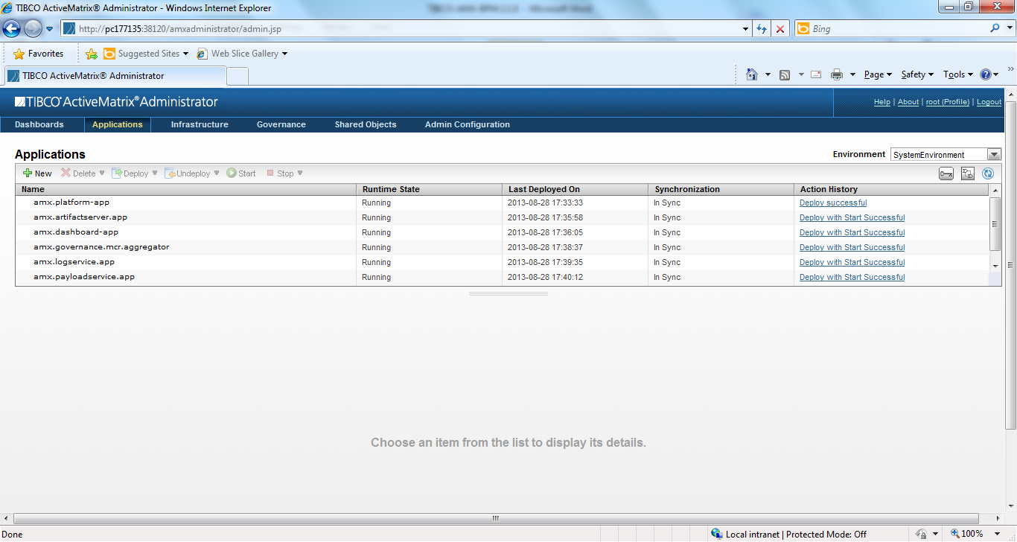

Following is the URL to open the workspace

URL : <http://10.226.188.170:38080/workspace/workspace.html>

User Name : root

Password : t